Oral presentation

Throughout the course we have been interested on estimating and evaluating the volatility and risk measures of a particular variable of interest. In our work, we applied all the different types of models we learned to estimate volatility and risk for our variable of interest: Swiss Stock Exchange using the SMI Index.

To begin with, we start by analyzing the nature of SMI time series of returns. As we know, time series cannot be perfectly predicted, they are a representation/observation of a stochastic process, one of the infinite possible outcomes. We evaluate if stylized facts, common characteristics, are present in our time series.

First, we evaluate the autocorrelogram function (ACF). In this test, we want to see whether previous observations are correlated with today’s observation. So, our null hypothesis is that there is not correlation with past returns , coefficients accompanying lagged returns are equal to zero. But, if we reject H0, is because the lagged return is statistically significant, and different to zero. Meaning, that lagged return is significant to explain today’s returns and we should take it into account in our model.

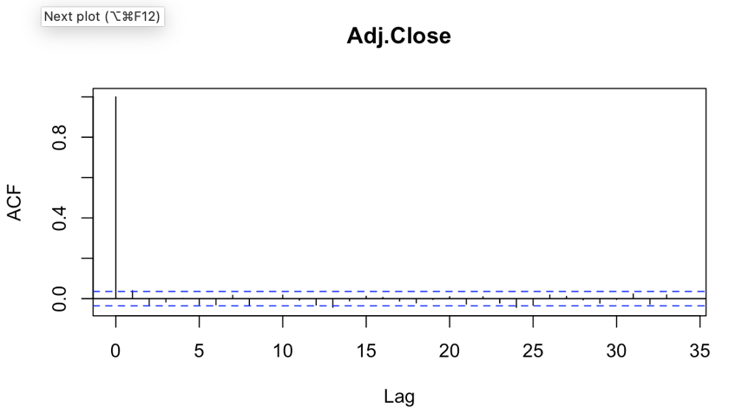

In this test, all those lags that exceed the nullity band mean that, according to our sample, there is evidence suggesting the correlation is significant. As we can see, there are no significant lags, today’s returns are not explained by past returns observations.

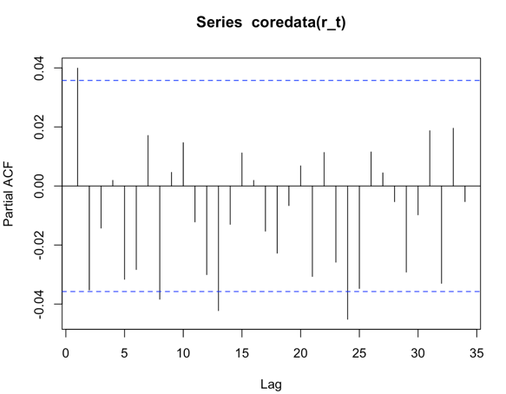Afterwards, we test the existence of partial autocorrelogram. In this test we see the direct effect of the lag return respect today’s return, eliminating the influence it contains from other lags (we do not consider the dependency created by the lags between them).

Again, according to the obtained results there is no evidence suggesting dependence between rt and rt-j. In consequence, we could assume that the expected value of the returns is equal to zero.

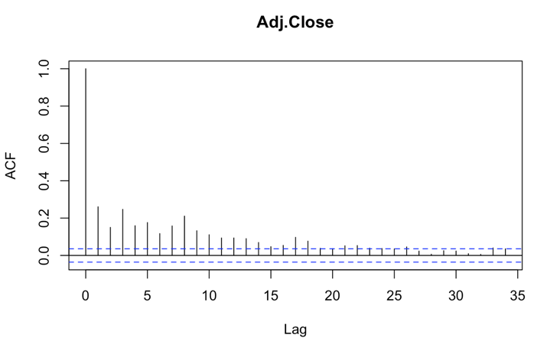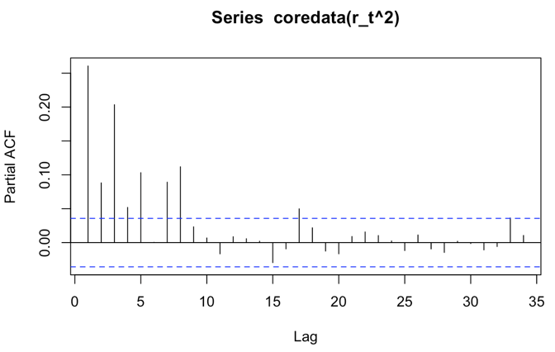However, results vary a lot if we transform the variable under analysis to squared returns. If we follow the same procedure than before, we see that dependency with recent lags are significantly different from zero, and then fall inside the nullity band.

This result suggest that shocks are not permanent, that are absorbed through time, and that we can model as there is no white noise process. This time series can be model, we can predict its variation. If we focus on the squared return, we will be modelling for the variance as we assume that mean of returns is equal to zero.

Later, we evaluate if the time series could be said to follow a normal distribution. For this, we must calculate its kurtosis and skewness to be able to carry on with the Jarque-Bera test.

We calculate the kurtosis, which is 9.45, much larger than 3 (kurtosis for a normal distribution). The interpretation of this result of fat tails is that there is a bigger probability of observing large returns and losses.

Then, we calculated the skewness from our time series. We got that it is equal to -0.86 (left skewness), which means that number of negative returns are higher than the number of positive returns.

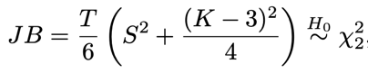After obtaining these values, we were able to test the Jarque-Bera to evaluate if the time series is normally distributed. The null hypothesis is that the series is normally distributed and the test statistic is:

Basically, the test is based in the difference between the sample skewness and kurtosis and the values of a normal distribution. In our case, the test statistic took the value of 11,601 (extremely large) with a p-value below 0.0000… meaning we should reject H0, the evidence suggests the time series does not follow a normal distribution. So, the 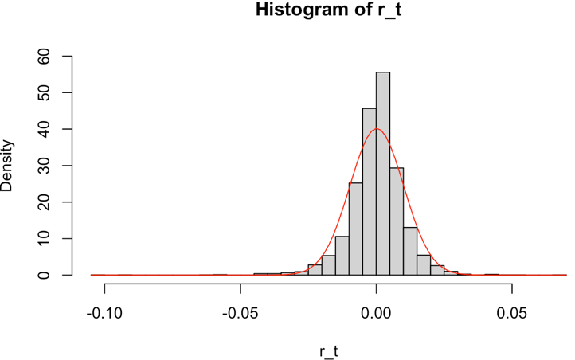assumption of normal distribution for the series would be very strong (note that returns concentrate around zero).

Moreover, we tested if the time series could be associated with a white noise.

One possible test is the Box-Pierce Test, where the null hypothesis is that the autocorrelation of the variable against the same lagged variable is equal to zero, meaning there is no relation between past returns. So, if we don’t reject H0 is because evidence suggests the series is a white noise process.

In our SMI time series (for r_t) the BP test statistic took a value of 11.82 with its corresponding p-value of 0.03 that led us to reject our null hypothesis (there is at least one significant lagged variable) and the series is not a white (DEBERIAMOS USAR LAG=50 PARA QUE NO RECHAZAR LA HIPOTESIS NULA)

Using lag=50 in our SMI time series for r_t, we do not reject H0 as took a value of 0.14 (BP=60.2), but we do reject when we test for r_t^2 (p-value=0.000…). These results are consistent with what we observed from the ACF and PACF, where the time series of r_t could be associated with a white noise process while it could be said the same for the squared returns. If we reject the null hypothesis, the evidence is suggesting there is at least one significant lagged variable (there is correlation), so we can model. But if we do not reject, we are saying that the correlation coefficients are not statistically different from zero, so the series is a white noise.

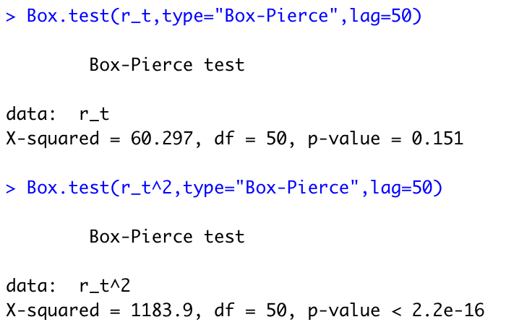

We also test this hypothesis with the Ljung-Box test. The results and conclusions are the same that with the Box-Pierce test: we reject the null hypothesis for the case of squared returns (there is a correlation that can be modeled) and we do not reject in the case of the absolute returns.

Also consistent with the interpretation of ACF and PACF graphs.

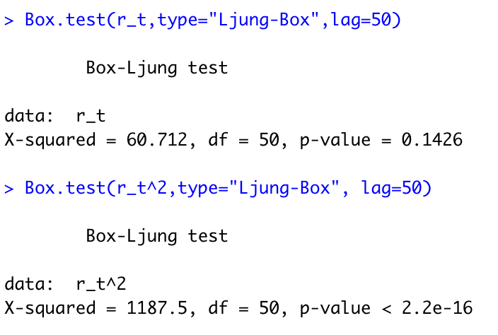

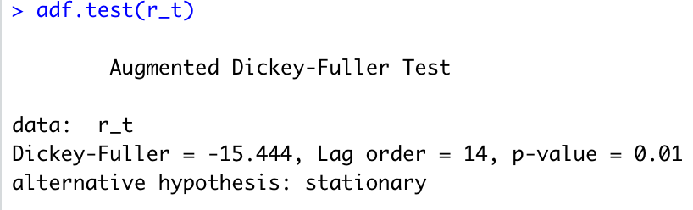Finally, regarding the tests that could be done for checking the stylized facts of the time series, we ran the Augmented Dickey Fuller Test. This test evaluates the existence of unit roots that implies that the process is no stationary because the influenced of lagged variables is not absorbed over time, shocks are permanent and cumulative, generating tendency. The results we obtained indicate that the process is stationary as the evidence suggests there is no presence of unit roots. Given the p-value=0.01, we reject the null hypothesis of the existence of unit roots.

When we finished testing the stylized facts on SMI series, we continued by estimating the conditional variance of SMI returns with several different models.



The first model we used is the GARCH (1,1) which equation is:

This model can be seen as an ARCH (∞), so GARCH (1,1) is more parsimonious. Also, this model includes a term for the Clustering Phenomenon, being one of its biggest virtues. This phenomenon is the idea that big changes in returns tend to be followed by big changes, and small volatility is followed with small volatility (of either sign), and it is represented in the last term, where they add the volatility of past period. Omega is the constant, alpha accompanies the explicative variable one-period lagged squared returns and beta does the same for one-period lagged variance.

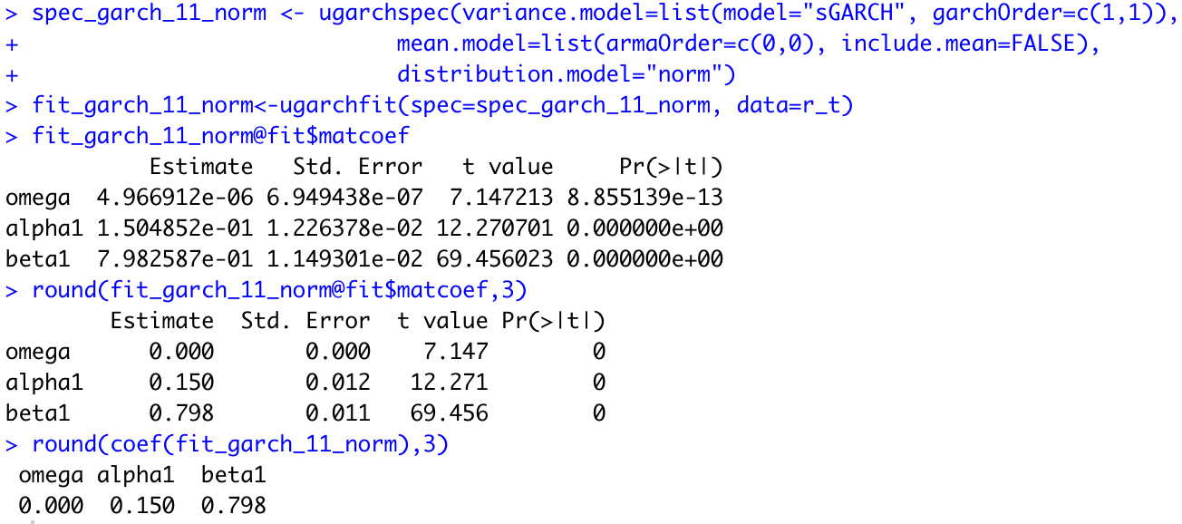

When we ran the model, we obtained that all estimated coefficients are greater than 0, fulfilling the restriction to have positive variance.

We obtained that all our variables are significant with a p-value close to 0.0000…

Moreover, as we can affirm that the process is stationary and volatility converges to the long run level.

However, this model is incapable of taking into account the Leverage Effect. We said that it was able to incorporate the relevance of past volatility and how it affected today’s volatility, but it gave the same importance to positive and negative volatility in returns. In reality, negative past returns have a bigger impact on today’s volatility than positive past returns. People usually expects profits, so when losses occur, the effect is bigger. This correlation is negative: when returns decrease, volatility increases. Therefore, we estimated using the GJR (1,1) model which adds a term that covers this effect using this equation:



Where gamma takes a value different of zero when past returns are negative. It adds volatility to the total volatility when there are losses in the past, incorporating the Leverage Effect into the model.

When we ran the model, we got:

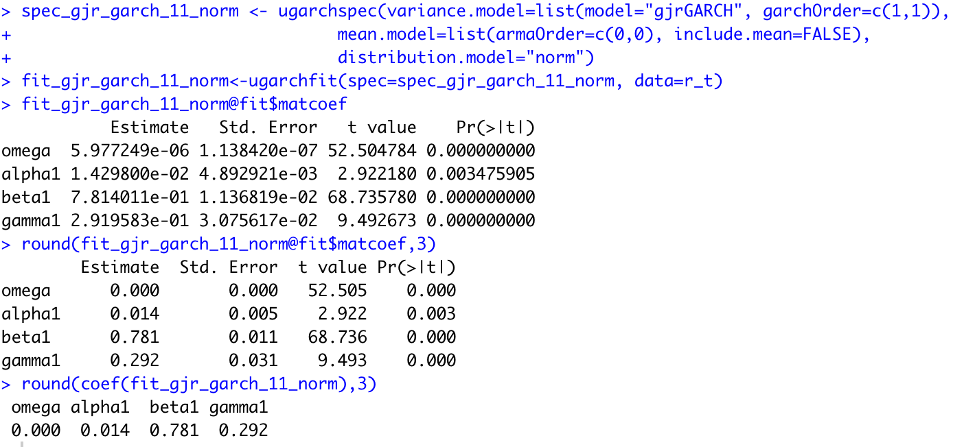

As you can see, the four variables are significant and respect the condition for positive variance. Also, under the assumption that the variable of interest follow a symmetric distribution, we have that the model is covariance stationary as (alpha + beta + gamma/2) < 1 (NO SE QUE SIGNIFICA, ASI QUE NO LO DIRIA EN EL ORAL)

As gamma is greater than 0, it means that volatility increases when past returns are negative.

If we assumed that the SMI time series follow a t-student distribution, we obtained the following results:

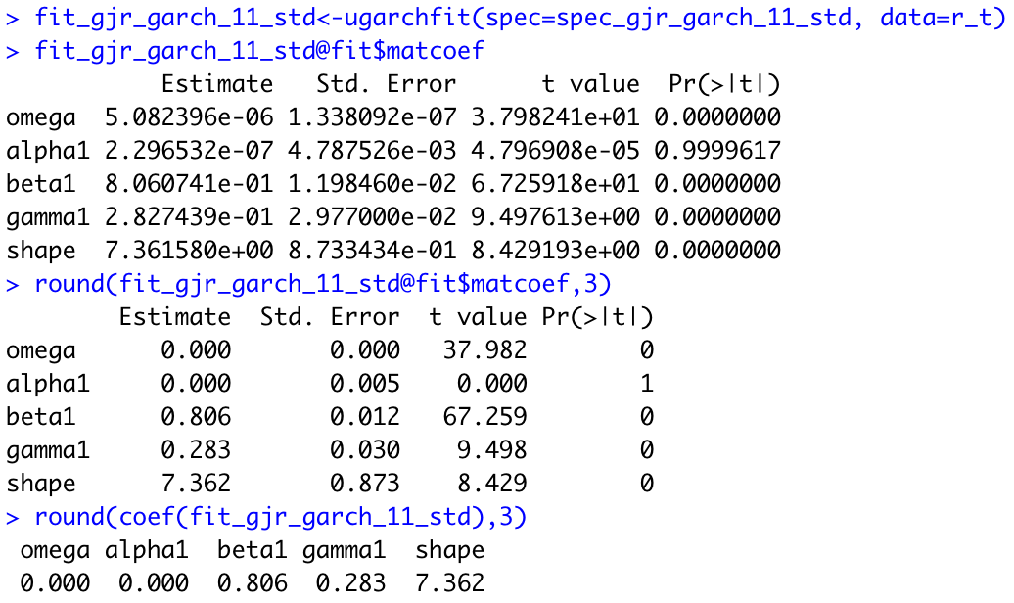

All coefficients are significant except for the variable accompanying alpha (r_t-1^2). According to these results, past squared returns are not relevant for explaining today’s volatility, but negative squared past returns are relevant, so there is some weird and questionable model performance.

NO TENGO NI IDEA QUE REPRESENTA EL COEFICIENTE “SHAPE” (USTEDES SABEN?)

Shape: it is related with the degrees of freedom of the model

Until now, we did not consider the skewness in our models which facilitated our jobs and prevent a bad performance from them. If we consider skewness, this can work as an outlier, adversely affecting the estimations from our model.

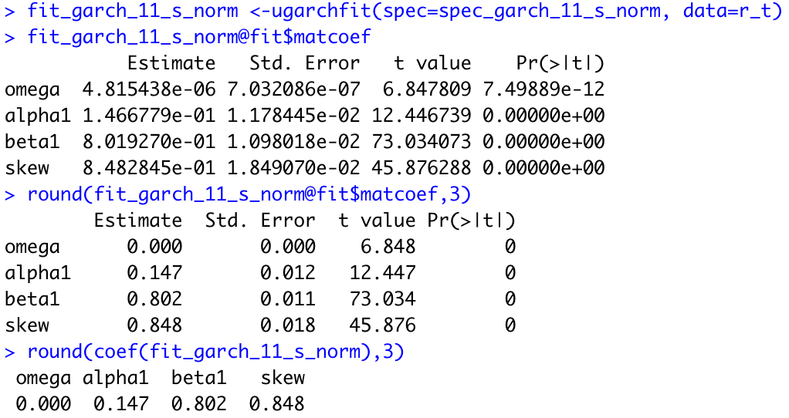

As we got in the beginning of the work, skewness is significant, meaning our data is skewed. Our previous models could be affected and worsen it results due to this fact.

Following the same procedure with the GARCH (1,1) adding skewness and assuming t-student distribution for SMI data.

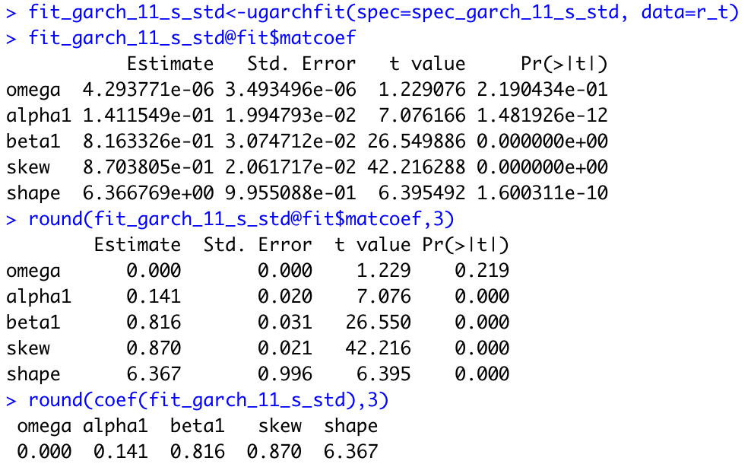

Once again, skewness is a significant variable in the model. But in this case, the constant variable is not, so we should remove it from the model.

Afterwards, we add the skewness to the GJR (1,1) model.

Assuming SMI follows normal distribution:

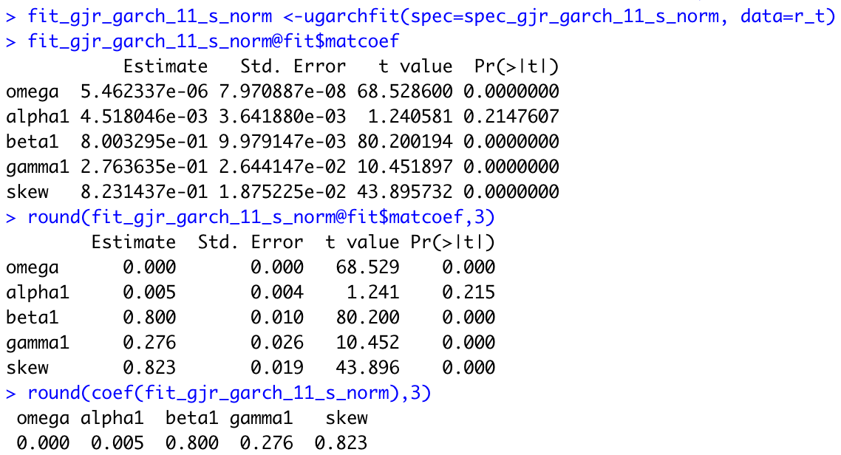

According to the results we got, there is evidence suggesting past squared returns are not significant for explaining volatility and being the skewness significant again.

If we assume t-student for SMI series:

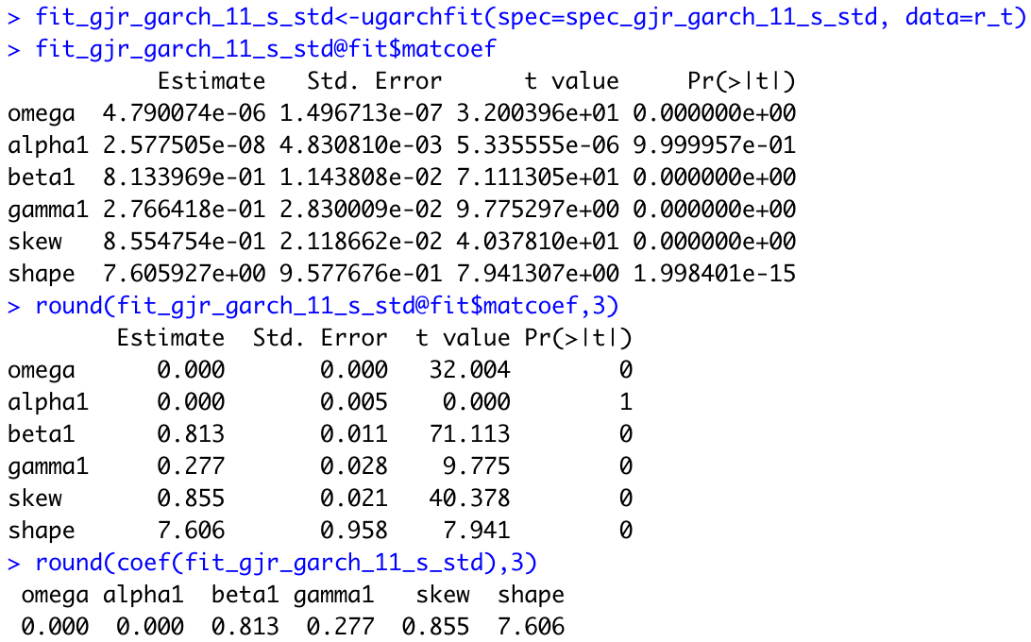

As before, all variables are significant according to the evidence, except for past squared returns.

GARCH-MIDAS

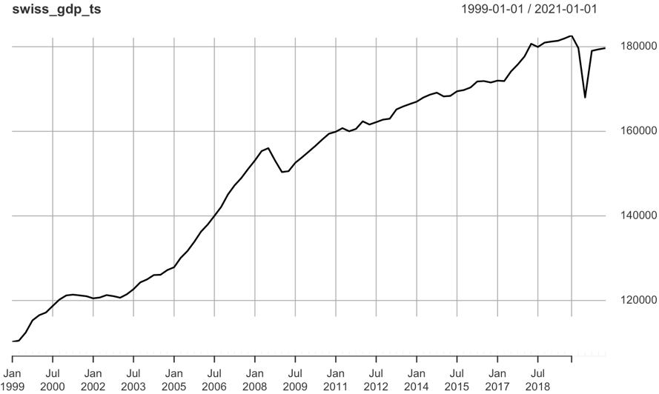In addition, there is an important aspect we could include in our models. Financial asset’s volatility can be highly influenced by macroeconomic variables due to agents’ expectations or announcements. Macroeconomic variables could act as determinants of volatility. These last weeks we saw the effects on the financial asset prices because the FED increased the interest rates. There are several models that can be seen as extensions of the standard GARCH that are able to include MV in the estimation. In our case, we chose the Swiss GDP (2010-2020) as the macroeconomic variable to add in our models to explain SMI volatility. By assumption, we treated the MV as strictly stationary.

The problem for this inclusion is that these variables have different frequency observations: while SMI returns can be observed with very high frequency (daily, hourly, every 5 minutes), MV are much more difficult to observe and could have a monthly frequency at the most.

For example, in our case, we took the quarterly data for the GDP in order to add it into the models.

One alternative for this kind of models is the GARCH-MIDAS model. This model attacks the frequency problem by decomposing the volatility in two components: the short-run component and the long-run. The former one is associated with the high frequency data and the long-run, with the low frequency (MV observations). In this model, the short run component varies with the same frequency of our dependent variable, and the long-run component filters low frequency observations of the macroeconomic variable to adjust it with the high frequency ones.

The GARCH-MIDAS model is defined as:

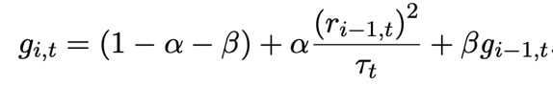Being ri,t the log returns for day i in the period t. We are still modelling for changes in daily earns and losses. Tau represents the long run component and g represents de short run component.

The short run component is defined as:

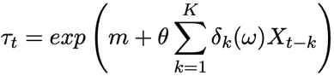

And the long run as:

So, the short run depends on the past squared returns and of past short run component.

And the long run depends of a constant (m) and the past realizations of the economic variable (Xt) weighed by delta (where recent realizations should weigh more) and theta is the coefficient that accompanies this macroeconomic variable (Swiss GDP).

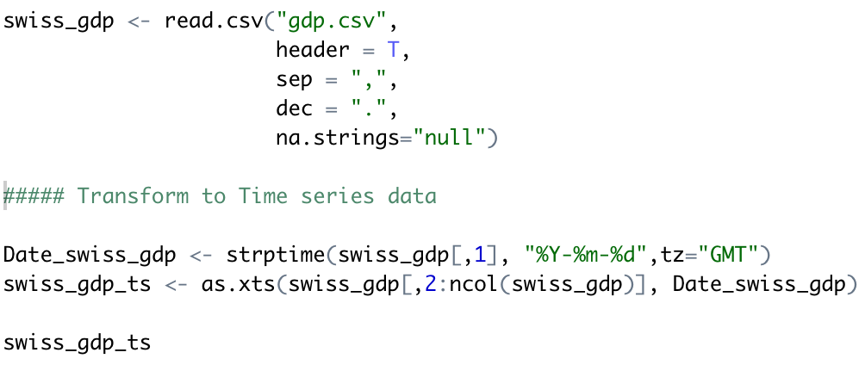Before estimating, we imported the Swiss GDP into our dataset and transformed it into a time series

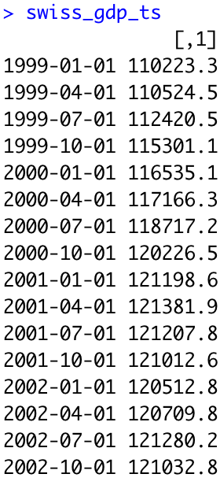Obtaining:

After that, we limited this information for the period 2010-2020, and transform it into a matrix with the following function:

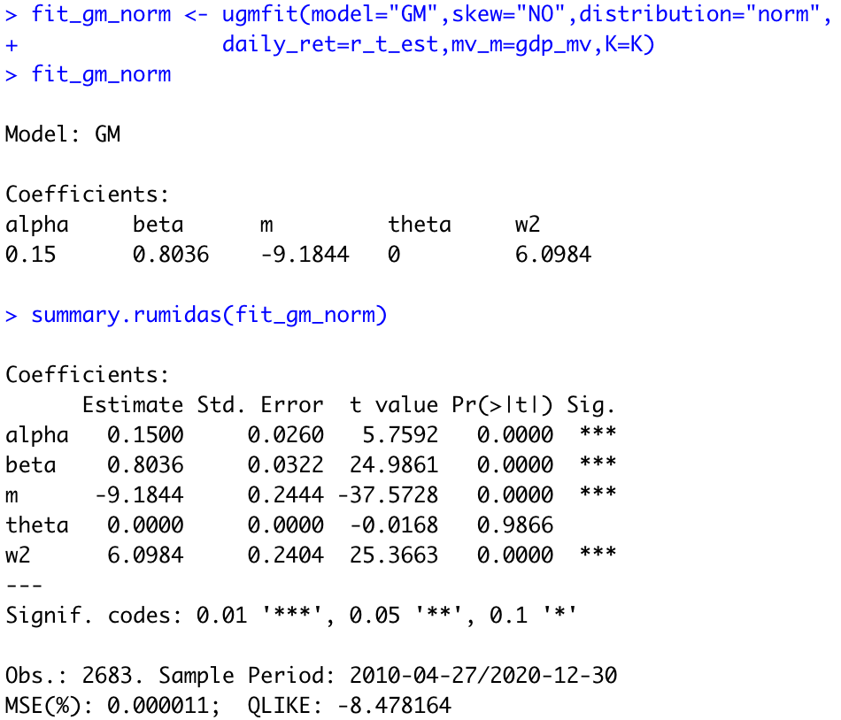Once we did these transformations, we were able to estimate using the GARCH-MIDAS without a skew parameter and assuming normal distribution.

The results of our estimation suggest that our macroeconomic variable is not significant to explain the SMI volatility, because theta is not rejected in any individual test. All the other variables are significant (even the constant of the long run component).

Then we added the skew parameter and run it again.

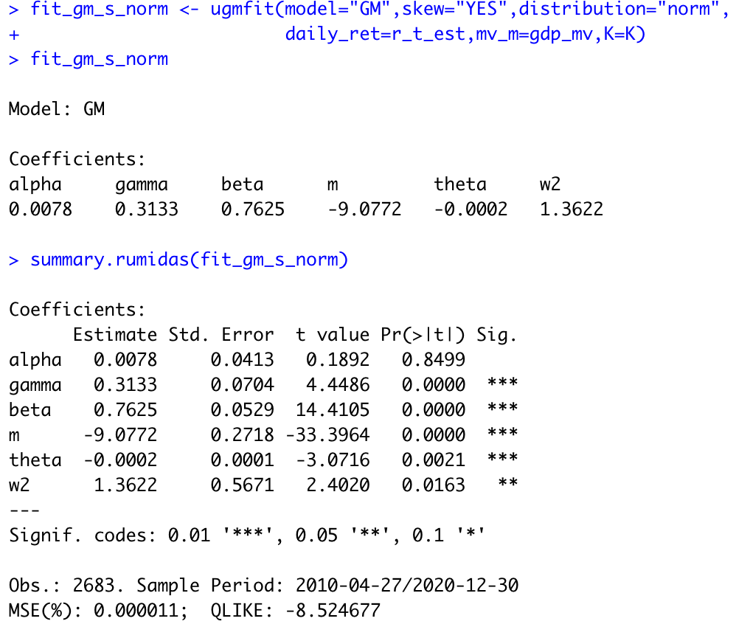

In this case, the past squared returns are not significant and past observations of the Swiss GDP are relevant to explain SMI volatility. The coefficient that determines the weight of recent or further MV observations is significant at 5% level of significance.

Finally, we did repeat this process assuming t-student distribution for our time series.

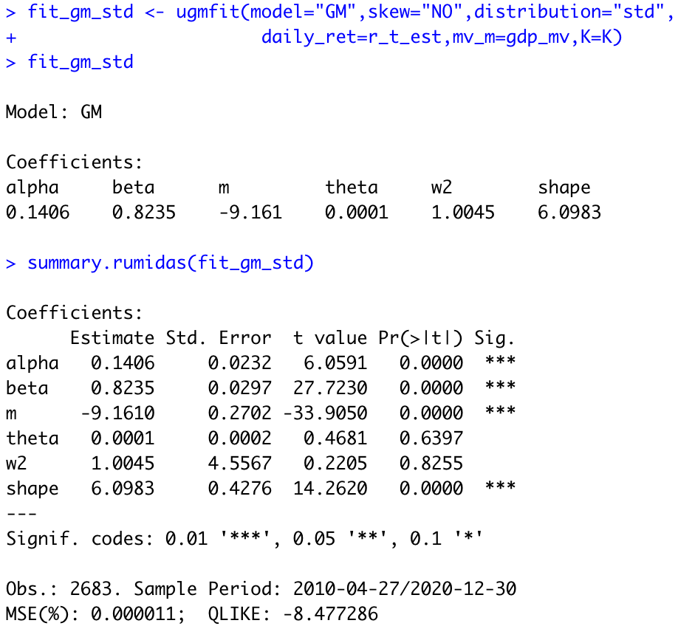First, without skew parameter:

Once again, when we don’t consider skew parameter, the MV is not significant and should be removed from the model.

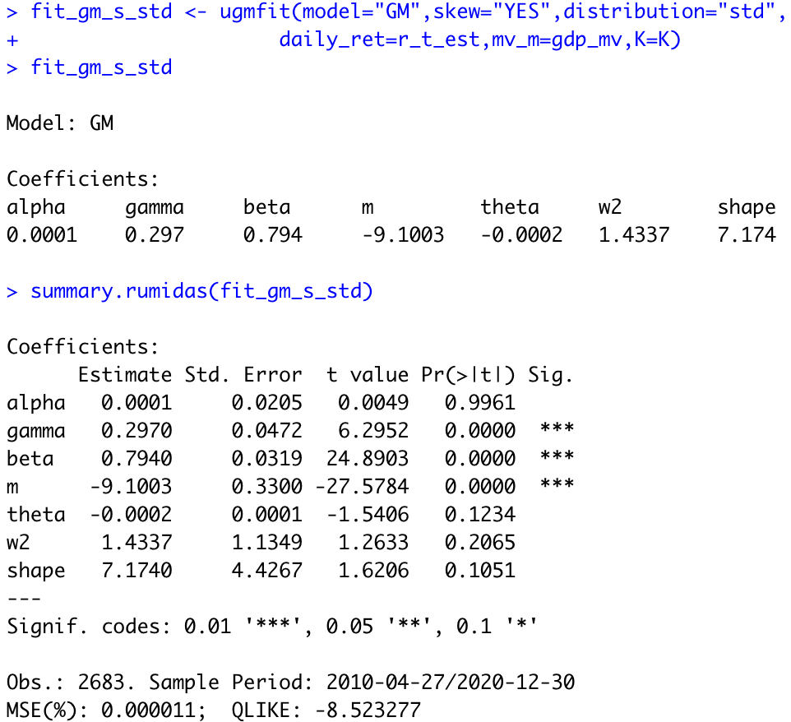When we added the skew parameter, the estimation gave us pretty bad results as the only significant variable are the skewness and previous short run components:

Some problems of the GARCH-MIDAS model are that is incapable of considering the Leverage Effect, as it does not include a term for adding extra volatility when past returns are negative. Also, this problem could be present in the long run component: recessions could have the same effect and increase volatility. This model does not solve this.

DAGM

The GARCH-MIDAS drawbacks are assessed and solved by the Double Asymmetric GARCH-MIDAS (DAGM) model. This model incorporates parameters to estimate the effect the “bad” news has over volatility: gamma is associated with the negative returns, theta (+) and theta (-) with the positive and negative Swiss GDP variations, respectively. Furthermore, it adds two weights to past MV observations depending their sign (recent negative values should weigh more than recent positive values on changing volatility).

The estimation is done the same as for the GARCH-MIDAS model. Assuming normal distribution, we obtained:

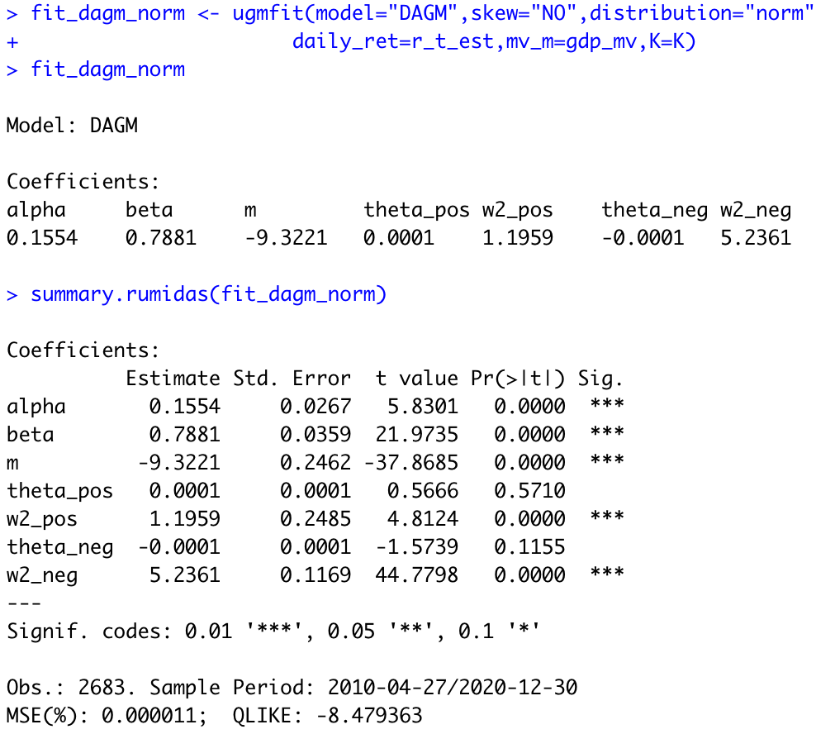

According to our estimations, the evidence suggests that we should not reject the null hypothesis which proposes that theta (+) and theta (-) are equal to zero. This means that the Swiss GDP is not relevant to explain SMI volatility.

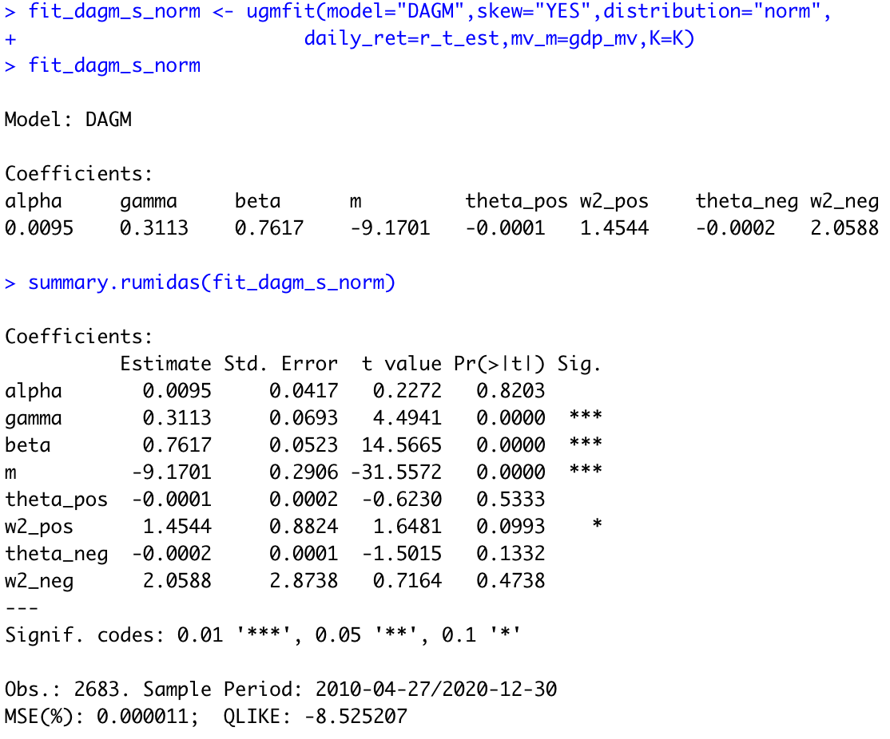When we added the skew parameter, we obtained:

The only significant variables are negative past squared returns, past short run component, constant from the long run component and positive past MV values (only from 10% significance level).

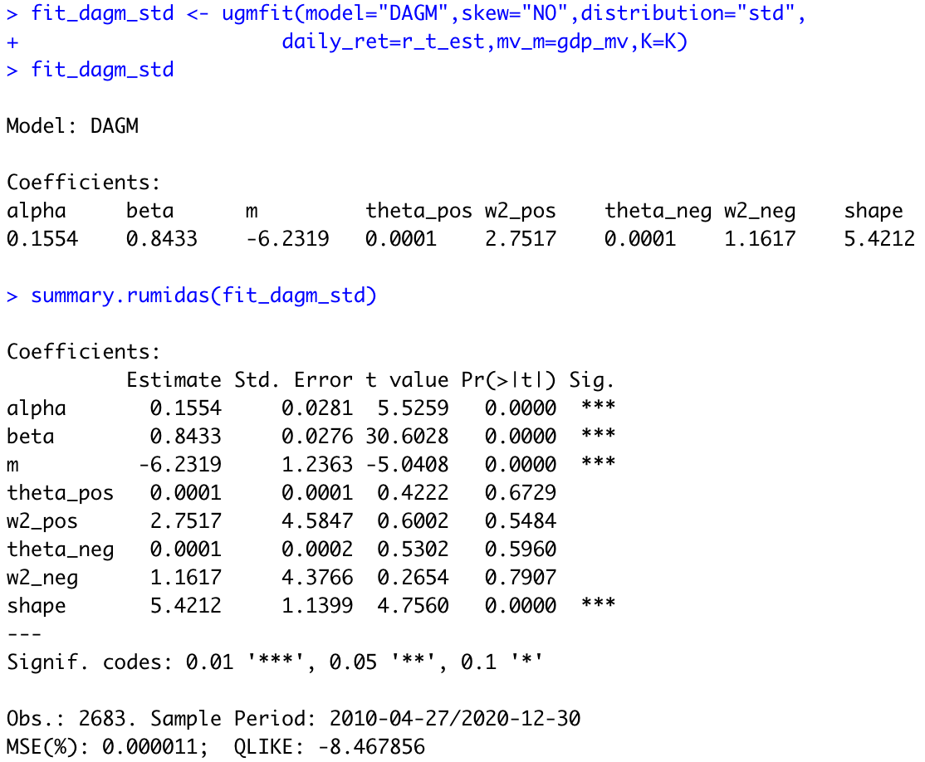Later, we did the same but assuming student distribution and no skewness. We obtained:

Once again, none of the parameters related to our macroeconomic variable are significant as an explicative variable of SMI volatility. This result is common in most of the estimations we did for this model so, we could say that Swiss GDP is not significant and would be a mistake to include it as a relevant variable.

If we estimate the same model, but adding the skew parameter, we have:

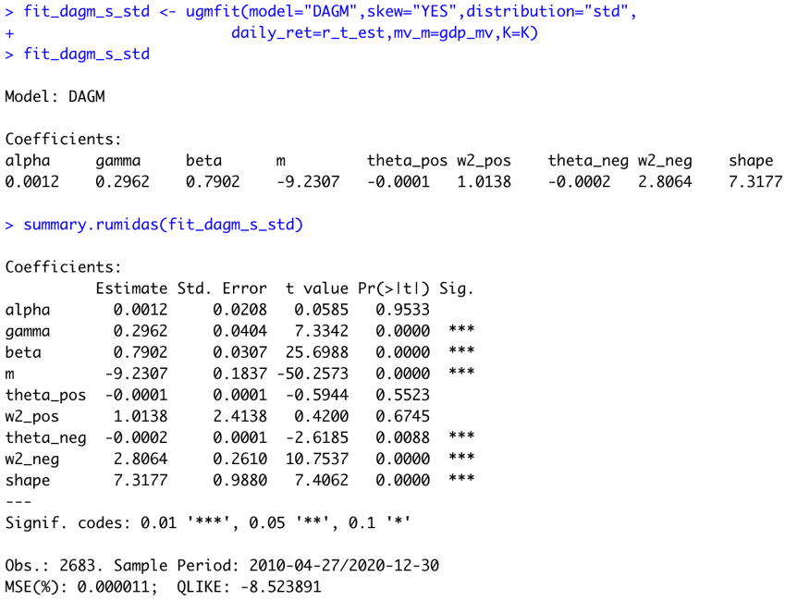

In this case, the evidence suggests that past squared returns and past positive values of the GDP are not relevant for the model. They can be discarded.